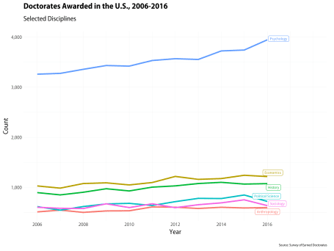

PhDs awarded in selected disciplines, 2006-2016.

[Thierry Rossier asked me](https://twitter.com/ThierryRossier/status/1142696462989611009?s=20) for the code to produce plots like the one above. The data come from the Survey of Earned Doctorates, a very useful resource for tracking trends in PhDs awarded in the United States. The plot is made with geom_line() and geom_label_repel(). The trick, if it can be dignified with that term, is to use geom_label_repel() on a subset of the data that contains the last year of observations only. That way we can label the endpoints in a nice way, which I think is often preferable to a key or legend that the reader has to refer to in order to decode the graph. The gghighlight package (<https://github.com/yutannihilation/gghighlight>) will do this for you in a single step. But this works, too.

Here’s the code for the plot shown here. Code and data for it and several others is available on GitHub at <https://github.com/kjhealy/earned_doctorates>.

library(tidyverse)

library(janitor)

library(socviz)

library(ggrepel)

## --------------------------------------------------------------------

## Custom font and theme, omit if you don't have the myriad library

## (https://github.com/kjhealy/myriad) and associated Adobe fonts.

## --------------------------------------------------------------------

library(showtext)

showtext_auto()

library(myriad)

import_myriad_semi()

theme_set(theme_myriad_semi())

phds <- read_csv("data/earned_doctorates_table.csv")

phds <- clean_names(gather(phds, year, n, `2006`:`2016`))

phds$year <- as.numeric(phds$year)

phds_all <- phds %>% group_by(discipline, year) %>%

tally(n)

p <- ggplot(phds_all, aes(x = int_to_year(year), y = n, color = discipline)) +

geom_line(size = 1.1) +

geom_label_repel(data = subset(phds_all, year == 2016),

aes(x = int_to_year(year), y = n,

label = discipline,

color = discipline),

size = rel(2.1),

nudge_x = 1,

label.padding = 0.2,

box.padding = 0.1,

segment.color = NA,

inherit.aes = FALSE) +

scale_y_continuous(labels = scales::comma) +

scale_x_date(breaks = int_to_year(seq(2006, 2016, by = 2)),

date_labels = "%Y") +

coord_cartesian(xlim = c(int_to_year(2006), int_to_year(2018))) +

guides(color = FALSE, label = FALSE) +

labs(x = "Year", y = "Count",

title = "Doctorates Awarded in the U.S., 2006-2016",

subtitle = "Selected Disciplines",

caption = "Source: Survey of Earned Doctorates")

ggsave("figures/socsci_phd_trends.png", p, width = 8, height = 6)